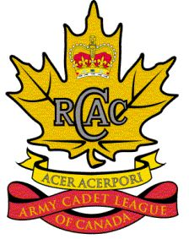
League Volunteer Shirt Order Form

Payment must be included with Order Form
Orders processed on a Quarterly basis Please send forms to:
The Army Cadet League of Canada (Ontario)
1200 Markham Rd., Ste 527
Toronto, ON M1H 3C3

Name: Cadet Corps #:
Mailing Address (no P.O. Box #):

Phone #:
E-Mail:

QTY | Mens | Womens | Size | Price  (tax incl) | Total
 |  |  | S | $35.00
 |  |  | M | $35.00
 |  |  | L | $35.00
 |  |  | XL | $35.00
 |  |  | XXL | $35.00
 |  |  | 3X | $40.00
 |  | Not  Available | 4X | $40.00
 |  | Not  Available | 5X | $40.00
Total number of items:
Subtotal:
Shipping and Handling: $10 per order
TOTAL:
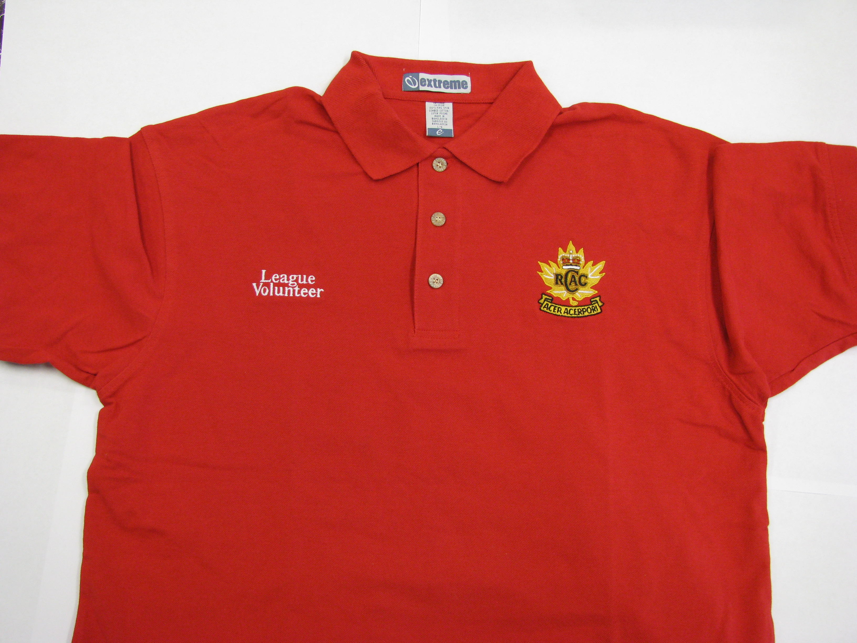

Description: red short sleeved golf shirt,
League Volunteer embroidered in white,
and the Army Cadet League crest in gold.

Please note that we accepts payment in Cash, Cheque or Money Orders
For any inquires please call our office at: 416-431-2792 or 1-800-561-4786

